***2022-23 Intramural Soccer***

We are very excited to begin a youth program for our future soccer Bearcats this spring! This league will be open to all students in K-6 grades. We will have three divisions K-1st, 2nd-4th, 5th-6th (subject to change depending on registration numbers). Games and practices will take place on Saturdays from April 15th – May 20th, May 27th will be a rainout date if needed. Each team will have skills work for 30 minutes followed by a 30-minute game versus another team within their division. All practices and games will take place at the Walton-Verona Sports Complex on the turf. Games/skills work sessions will begin every hour, on the hour, from 5:00 pm-8:00 pm starting with the youngest group (subject to change depending on numbers).

The cost for the league will be $75/player. The registration fee includes a team colored shirt and six practices/games. Each team will be coached by current Walton-Verona Soccer players/coaches.

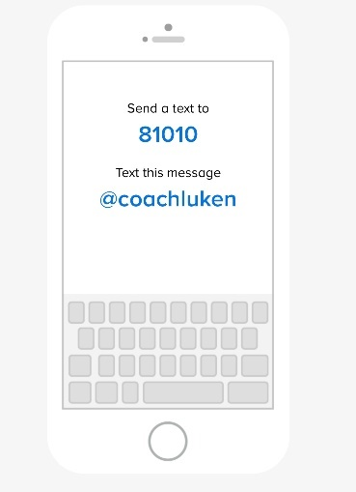Registration fees and forms are due by Sunday, April 9th. If your child is not registered by April 9th we can’t guarantee they will have a shirt on April 15th. All families are encouraged to register their child for intramurals online by going to <https://gofan.co/app/events/951819>. This link will also be posted on the athletics website and sent out by building Administrators. However, if you would rather register in person, we will hold an in-person registration event on March 29th from 5:00 PM - 6:00 PM in the high school gym lobby.

During the first Saturday of the league, we will place players on teams according to similar size and skill to the best of our ability. Shirts will also be passed out on the 15th. All players will need to bring their own shin guards and water. Players are encouraged to bring their own ball and wear soccer cleats, but it is not required.

All parents will need to join the Soccer Intramural Remind101 as this will be our primary form of communication to set official times once registration is closed and to cancel if needed. To join please text @coachluken to 81010 or follow <https://www.remind.com/join/coachluken>.

Please email [Patrick.Luken@wv.kyschools.us](mailto:Patrick.Luken@wv.kyschools.us) with any questions.

­­­­­­­­­

Players Name: __________________________________________________________

Age: __________ Grade: __________________ Shirt Size: ______________

Address: _______________________________________________________________

City: __________________ State: ___________________

Zip: ___________________ School: _________________

Email Address: ___________________________________________________________

**I hereby authorize the staff of the Little Bearcats league to act for me in accordance with their best judgement in any emergency requiring medical attention. I hereby waive and release the team/school from any and all liability for any injuries or illnesses incurred during the league. I have no knowledge of any physical impairment that would be affected by the named student’s participation in the league.**

Parent Name: ________________________________________________________

Parent Signature: ____________________________________________________________

Phone #: ____________________________________________